Ruan Small

27027228

ITRW 311

Assignment 1

22 February 2017

**Index**

Part A – Question 1 ________________________________________________ 3

Question 2 _______________________________________________________ 3

Question 3 _______________________________________________________ 4

Question 4 _______________________________________________________ 4

Question 5 _______________________________________________________ 4

Part B – Question 1 ________________________________________________ 5

Question 2 _______________________________________________________ 5

Question 3 _______________________________________________________ 5

Question 4 _______________________________________________________ 5

Question 5 _______________________________________________________ 5

Question 6 _______________________________________________________ 5

Part C – Question 1 ________________________________________________ 6

Question 2 _______________________________________________________ 6

Question 3 _______________________________________________________ 7

Question 4 _______________________________________________________ 7

Question 5 _______________________________________________________ 8

Question 6 _______________________________________________________ 8

Refrences ________________________________________________________ 8

**Part A**

1. a. Data are raw facts which must yet be manupilated or processed to provide meaningful information.

**Example:** “Jessie” – which is a name.

“0165254982” – which is a telephone number.

b. A field is a data entry of a record. It consists of a collection of characters that provides for a meaning. A field basically possess defined data.

**Example:** “EB28” – which is a generated employee code.

“0825469834” – which is a cellphone number of the employee.

c. A record consists of logically connected fields that describes an object like for example a thing, person or place.

**Example:** The record for an employee can contain relevant fields such as his name (“Jessie”), employee code (“EB28”) and his cellphone number (“0825469834”).

d. A file consists of a group of relevant records. All records that are part of some group are placed under one file.

**Example:** A file which possess records of all the different employees working at a specific organization.

1. Data independence means that a person can change the characteristics of the data storage without changing the way an application would go by accessing the data.

It lacks in file systems because it does not possess any practical significance to logical data or physical data format, meaning it does not have any significance towards how humans view the data or towards how the computer goes by working with the data.

|  |  |  |  |  |  |  |  |  |  |  |  |
| --- | --- | --- | --- | --- | --- | --- | --- | --- | --- | --- | --- |
| **Types of Databases** | | | | | | | | | | | |
| **Type** | **Number of users** | | | **Site Location** | | **Database use** | | **Type of data** | | **Degree of data structure** | |
| **Single user** | **Multi User** | | **Centralized** | **Distributed** | **Operational** | **Analytical** | **General-purpose** | **Discipline-specific** | **Unstructured data** | **Structured data** |
| **Workgroup** | **Enterprise** |
| MS Access | **X** | **X** |  | **X** |  | **X** |  | **X** | **X** | **X** | **X** |
| MS SQL Server | **X** | **X** | **X** | **X** | **X** | **X** | **X** | **X** | **X** | **X** | **X** |
| IBM DB2 | **X** | **X** | **X** | **X** | **X** | **X** | **X** | **X** | **X** | **X** | **X** |
| MySQL | **X** | **X** | **X** | **X** | **X** | **X** | **X** | **X** | **X** | **X** | **X** |
| Oracle RDBMS | **X** | **X** | **X** | **X** | **X** | **X** | **X** | **X** | **X** | **X** | **X** |

1. Without database design, users tend to create databases according to their own view of the data, which is not suffiecent. DBMS require good and suffiecent databases to perform at their best. If the database is not of good structure, then the DBMS will not perform very well. It is important that the database is designed well because data is one of an organization’s most important assets, therefore it is crucial that the data is handeled carefully and precise. Data must be used properly so that the business can fully benefit from it.

|  |  |
| --- | --- |
| **Unstructured Data** | **Structured Data** |
| Email | Library Catalogues |
| PDF Files | Census Records |
| Spreadsheets | Economic Data |
| Video | Phone Book |

Unstructured data are raw facts or data which does not have a lot of meaning. A good example is the number 10 is raw data as it does not have any significant meaning, but if it was 10 kilometers, it would be structured data as it indicated distance.   
Therefore, structured data has more meaning and would rather be prevalent to the business environment.

**Part B**

1. This file contains 7 records and each record has 5 fields.
2. The problem would be that there is no separate field for city names, which means the application program using the database would net additional code to breakdown the MANAGER_ADRESS strings for the city name.   
   I would change the database structure and add a separate field to store the city names.
3. I would make each field (attribute) more specific, meaning I would have to break down the PROJECT_MANAGER and MANAGER_ADRESS fields and add additional fields to store data such as last name, area code, city, state or zip code.
4. The person with the name “Holly B. Parker” is shown 3 times with 3 different project codes. This same person or name also has the same phone numbers and adresses, which shows redundancy, because if her adress or phone number would change, all 3 instances of her entries would have to be changed also. If it happens that not all 3 occurences are changed, it would lead to inaccurate or untrustworthy data.
5. The continues use of last name, first name and initials while there are multiple occurences of the same teacher leads to redundant data. The multiple occurences could lead to data inconsistancies, as already revealed in the figure with Maria Cordoza having different initials.

I would suggest rather assigning a teacher ID to each teacher.

1. The ROOM_CODE would also have to change, but assumably won’t, leading to data anomolies or inconsistancy.

**Part C**

1. One COURSE has many CLASS.  
   One CLASS is generated by one COURSE.  
     
   One CLASS can be mentioned in many ENROLL – ments.  
   One ENROLL- ment mentions one CLASS.

* A student cannot enroll for the same class more than once.

Each entity of ENROLL-ment has one STUDENT.  
 One STUDENT has many instances of ENROLL-ment.

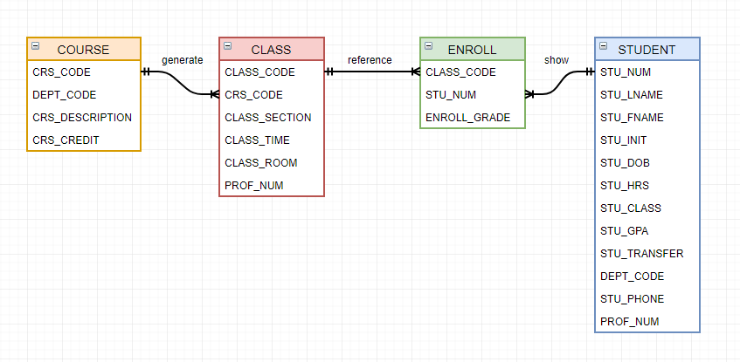

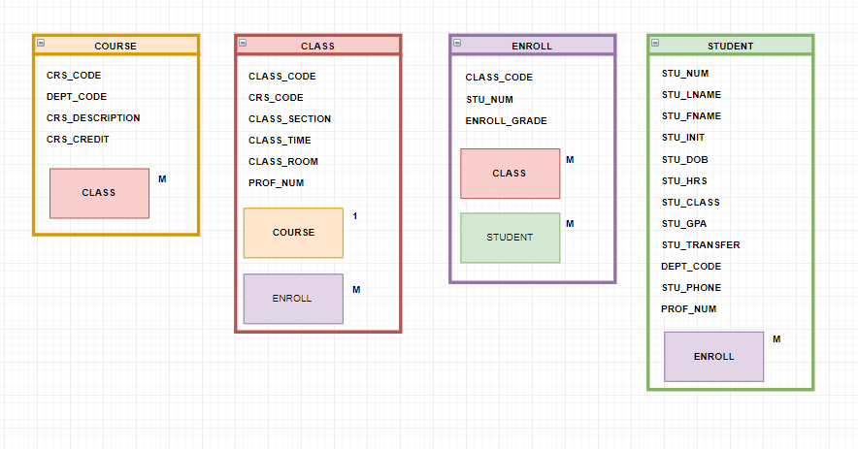

1. A) A patient can make 1 or more orders while and order can only be made by one patient.  
   An order can have one or more medication on it, but every instance of medication can have 1 order.

B)

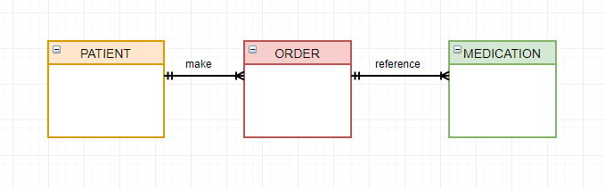

1. I would create 3 tables which will be, PAINTER, GALLERY and PAINTING.

|  |  |
| --- | --- |
| **Table Name** | **Attributes** |
| **PAINTER** | PAINTER_INITIAL |
| PAINTER_FNAME |
| PAINTER_LNAME |
| PAINTER_ID |
| **GALLERY** |  |
| GAL_NAME |
| GAL_ID |
| GAL_ADRESS |
|  |
| **PAINTING** | PAINTING_NAME |
| PAINTING_NUM |
| PAINTER_ID |
| GAL_ID |

1. A professor can advise many students.  
   Each student is advised by one professor.  
     
   A professor can teach many classes.  
   Each class is teached by one professor.

**Refrences:**

* Types of Databases, Learn About Different Kinds of Databases. 2018. Types of Databases, Learn About Different Kinds of Databases. [ONLINE] Available at: http://www.shawacademy.com/web-development/different-types-of-databases.html?s-page=true. [Accessed 22 February 2018]
* tutorialspoint.com. 2018. DBMS Data Independence. [ONLINE] Available at: https://www.tutorialspoint.com/dbms/dbms_data_independence.htm. [Accessed 22 February 2018].
* Techopedia.com. 2018. What is Data Independence? - Definition from Techopedia. [ONLINE] Available at: https://www.techopedia.com/definition/1178/data-independence. [Accessed 22 February 2018].
* Basic Database Concepts. 2018. Basic Database Concepts. [ONLINE] Available at: http://wserver.flc.losrios.edu/~davis/Chapter1.htm. [Accessed 22 February 2018].